Lesson 7: Algebraic Expressions—The Commutative and Associative Properties

Classwork

Exercise 1

Suzy draws the following picture to represent the sum $3+4$:

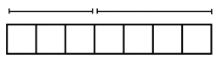

Ben looks at this picture from the opposite side of the table and says, “You drew $4+3$.”

Explain why Ben might interpret the picture this way.

Exercise 2

Suzy adds more to her picture and says, “The picture now represents $\left(3+4\right)+2$.”

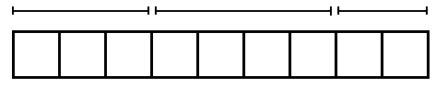

How might Ben interpret this picture? Explain your reasoning.

Exercise 3

Suzy then draws another picture of squares to represent the product $3×4$. Ben moves to the end of the table and says, “From my new seat, your picture looks like the product $4×3$.”

What picture might Suzy have drawn? Why would Ben see it differently from his viewpoint?

Exercise 4

Draw a picture to represent the quantity $\left(3×4\right)×5$ that also could represent the quantity $(4×5)×3$ when seen from a different viewpoint.

**Four Properties of Arithmetic:**

**The commutative property of addition**: If $a$ and $b$ are real numbers, then $a+b=b+a$.

**The associative property of addition**: If $a$, $b$, and $c$ are real numbers, then $\left(a+b\right)+c=a+(b+c)$.

**The commutative property of multiplication**: If $a$ and $b$ are real numbers, then $a×b=b×a$.

**The associative property of multiplication**: If $a$, $b$, and $c$ are real numbers, then $\left(ab\right)c=a(bc)$.

Exercise 5

Viewing the diagram below from two different perspectives illustrates that $\left(3+4\right)+2$ equals $2+(4+3)$.



Is it true for all real numbers $x$, $y$, and $z$ that $\left(x+y\right)+z$ should equal $\left(z+y\right)+x$?

(Note: The direct application of the associative property of addition only gives $\left(x+y\right)+z=x+(y+z)$.)

Exercise 6

Draw a flow diagram and use it to prove that $\left(xy\right)z=\left(zy\right)x$ for all real numbers $x$, $y$, and $z$.

Exercise 7

Use these abbreviations for the properties of real numbers, and complete the flow diagram.

$C_{+}$ for the commutative property of addition

$C_{×}$ for the commutative property of multiplication

$A_{+}$ for the associative property of addition

$A_{×}$ for the associative property of multiplication

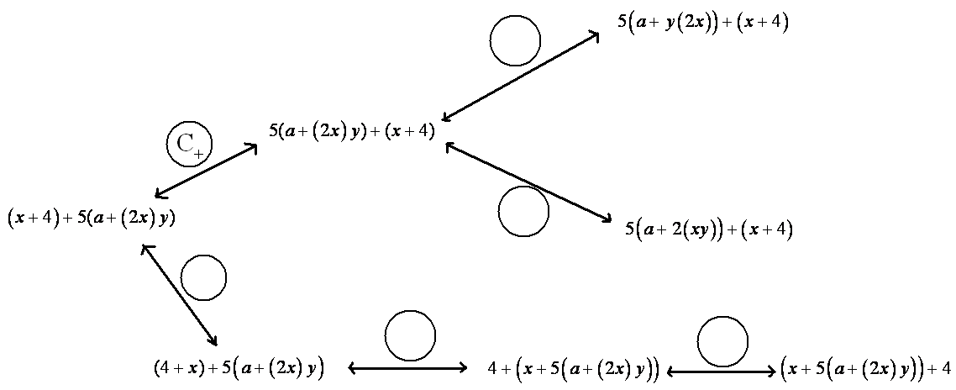

Exercise 8

Let $a$, $b$, $c$,and $d$ be real numbers. Fill in the missing term of the following diagram to show that $\left(\left(a+b\right)+c\right)+d$ is sure to equal $a+\left(b+\left(c+d\right)\right)$.



**Numerical symbol**: A *numerical symbol* is a symbol that represents a specific number.

For example, $0$, $1$, $2$, $3$, $\frac{2}{3}$, $-3$, $-124.122$, $π$, $e$ are numerical symbols used to represent specific points on the real number line.

**Variable symbol**: A *variable symbol* is a symbol that is a placeholder for a number.

It is possible that a question may restrict the type of number that a placeholder might permit (e.g., integers only or positive real numbers).

**Algebraic expression**: An *algebraic expression* is either

1. A numerical symbol or a variable symbol, or
2. The result of placing previously generated algebraic expressions into the two blanks of one of the four operators $((__)+(__), (__)-(__), (__)×(__), (__)÷(__))$ or into the base blank of an exponentiation with an exponent that is a rational number.

Two algebraic expressions are *equivalent* if we can convert one expression into the other by repeatedly applying the commutative, associative, and distributive properties and the properties of rational exponents to components of the first expression.

**Numerical expression**: A *numerical expression* is an algebraic expression that contains only numerical symbols (no variable symbols), which evaluate to a single number.

The expression $3÷0$, is not a numerical expression.

**Equivalent numerical expressions**: Two numerical expressions are *equivalent* if they evaluate to the same number.

Note that $1+2+3$ and $1×2×3$, for example, are equivalent numerical expressions (they are both $6$), but $a+b+c$ and $a×b×c$ are not equivalent expressions.

Lesson Summary

The commutative and associative properties represent key beliefs about the arithmetic of real numbers. These properties can be applied to algebraic expressions using variables that represent real numbers.

Two algebraic expressions are ***equivalent*** if we can convert one expression into the other by repeatedly applying the commutative, associative, and distributive properties and the properties of rational exponents to components of the first expression.

Problem Set

1. The following portion of a flow diagram shows that the expression $ab+cd$ is equivalent to the expression $dc+ba$.

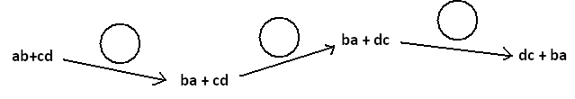

Fill in each circle with the appropriate symbol: Either $C_{+}$ (for the commutative property of addition) or $C_{×}$ (for the commutative property of multiplication).

1. Fill in the blanks of this proof showing that $(w+5)(w+2)$ is equivalent to $w^{2}+7w+10$. Write either commutative property, associative property, or distributive property in each blank.

$(w+5)(w+2)$ $=\left(w+5\right)w+(w+5)×2$

$=w\left(w+5\right)+(w+5)×2$

$=w\left(w+5\right)+2(w+5)$

$=w^{2}+w×5+2(w+5)$

$=w^{2}+5w+2(w+5)$

$=w^{2}+5w+2w+10$

$=w^{2}+(5w+2w)+10$

$=w^{2}+7w+10$

1. Fill in each circle of the following flow diagram with one of the letters: C for commutative property (for either addition or multiplication), A for associative property (for either addition or multiplication), or D for distributive property.

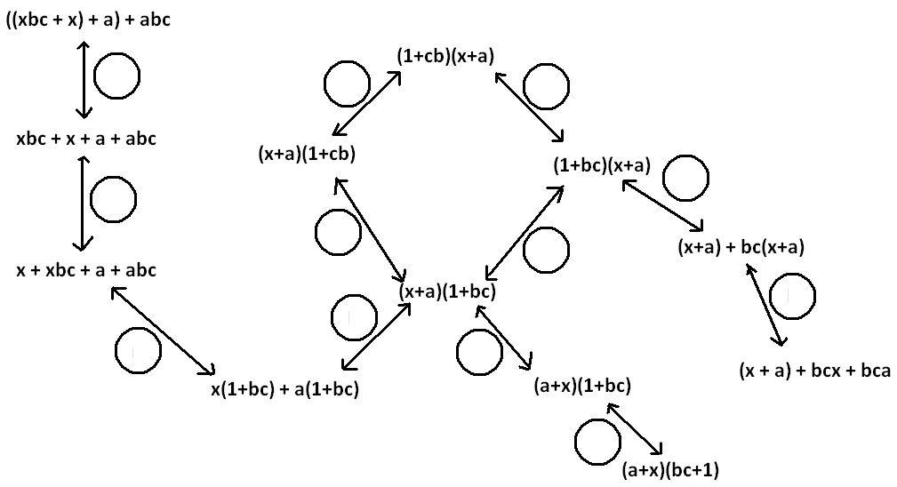

1. What is a quick way to see that the value of the sum $53+18+47+82$ is $200$?
   1. If $ab=37$ and $=\frac{1}{37}$, what is the value of the product $x×b×y×a$?
   2. Give some indication as to how you used the commutative and associative properties of multiplication to evaluate $x×b×y×a$ in part (a).
   3. Did you use the associative and commutative properties of addition to answer Question 4?
2. The following is a proof of the algebraic equivalency of ${\left(2x\right)}^{3}$ and $8x^{3}$. Fill in each of the blanks with either the statement *commutative property* or *associative property*.

${\left(2x\right)}^{3}$ $=2x∙2x∙2x$

$=2\left(x×2\right)\left(x×2\right)x$

$=2\left(2x\right)\left(2x\right)x$

$=2∙2\left(x×2\right)x∙x$

$=2∙2\left(2x\right)x∙x$

$=(2∙2∙2)(x∙x∙x)$

$=8x^{3}$

1. Write a mathematical proof of the algebraic equivalency of ${\left(ab\right)}^{2}$ and $a^{2}{b }^{2}$.
   1. Suppose we are to play the $4$-number game with the symbols $a$, $b$, $c$, and $d$ to represent numbers, each used at most once, combined by the operation of addition ONLY. If we acknowledge that parentheses are unneeded, show there are essentially only $15$ expressions one can write.
   2. How many answers are there for the multiplication ONLY version of this game?
2. Write a mathematical proof to show that $(x+a)(x+b)$ is equivalent to $x^{2}+ax+bx+ab$.
3. Recall the following rules of exponents:

|  |  |  |
| --- | --- | --- |
| $x^{a}∙x^{b}=x^{a+b}$ | $$\frac{x^{a}}{x^{b}}=x^{a-b}$$ | $${\left(x^{a}\right)}^{b}=x^{ab}$$ |
| $${\left(xy\right)}^{a}=x^{a}y^{a}$$ | $${\left(\frac{x}{y}\right)}^{a}=\frac{x^{a}}{y^{a}}$$ |  |

Here $x$, $y$, $a$, and $b$ are real numbers with $x$ and $y$ nonzero.

Replace each of the following expressions with an equivalent expression in which the variable of the expression appears only once with a positive number for its exponent. (For example, $\frac{7}{b^{2}}$ $∙b^{-4}$ is equivalent to $\frac{7}{b^{6}}$.)

$(16x^{2})÷(16x^{5})$

${\left(2x\right)}^{4}{\left(2x\right)}^{3}$

$\left(9z^{-2}\right){\left(3z^{-1}\right)}^{-3}$

$\left(\left(25w^{4}\right)÷\left(5w^{3}\right)\right)÷\left(5w^{-7}\right)$

$(25w^{4})÷\left(\left(5w^{3}\right)÷\left(5w^{-7}\right)\right)$

Optional Challenge:

1. Grizelda has invented a new operation that she calls the *average operator*. For any two real numbers $a$ and $b$, she declares $a ⨁{b}$ to be the average of $a$ and $b$:
 $$a ⨁ b=\frac{a+b}{2}$$

  1. Does the average operator satisfy a commutative property? That is, does $a⨁{b}=b⨁{a}$ for all real numbers $a$ and $b$?
   2. Does the average operator distribute over addition? That is, does $a⨁\left(b+c\right)=\left(a⨁b\right)+\left(a⨁c\right)$ for all real numbers $a$, $b$, and $c$?